

CS214: Design & Analysis of Algorithms SCIMS, FSTE

Final Examination Semester II, 2018

F2F/Blended Mode

Duration of Exam: 3 hours + 10 minutes

Reading Time: 10 minutes

Writing Time: 3 hours

Total Marks: 40

Instructions:

1. Write your answers in the space provided in this Question Paper.
2. Answer all questions. There are 12 questions and all questions are compulsory.
3. This exam is worth 40% of your overall mark. The minimum mark to pass the final exam is 16/40.
4. Total number of pages including this cover sheet is 16.
5. This is a closed book exam. No printed materials and electronic devices are allowed.

ID:___________________________ Name:_____________________________

SeatNo: _______________________

This page is intentionally left blank

Page 2 of 16
ID: _______________________

Division

1st Division

2nd Division

3rd Division
Category

6 winning Numbers

5 winning Numbers

4 winning Numbers
Amount

$1,000,000 / total winners of 1st Division

$100,000 / total winners of 2nd Division

$10,000 / total winners of 3rd Division

1. Why a Hash Table?
A hash table provides an efficient way to store and retrieve player data, particularly the email and mobile number of the winners, in constant average time O(1)O(1)O(1). In this scenario, every player’s email and mobile number must be stored, and once the system determines the winners, it needs to look up and send notifications efficiently.
2. Justification:
- Fast Insertion and Lookup:
  - Each player's email and mobile number can be stored in a hash table as key-value pairs. The key can be a combination of the player's unique identifiers (like their name or mobile number) or simply their mobile number. The value can be additional data such as the player's email or whether they are a winner. Since a hash table provides average-case O(1)O(1)O(1) time complexity for both insertions and lookups, it allows efficient storage and fast access to player information when notifying winners.
- Handling Collisions:
  - While hash tables may suffer from collisions, these can be resolved using common techniques like chaining (linked lists for collisions) or open addressing. Given that players' mobile numbers or email addresses are likely to be unique, the chance of collisions will be minimal.
- Memory Efficiency:
  - A hash table is a memory-efficient solution because it only stores player data once, and only for those who have provided valid mobile numbers and emails. There is no need for complex structures like trees or linked lists to handle this, keeping memory usage minimal.
- Unbiased Random Selection:
  - The system needs to randomly pick winners based on the numbers they selected. This can be done efficiently by scanning through the hash table and identifying the winners who meet the specific division criteria (1st Division, 2nd Division, etc.). Once the winners are identified, retrieving their contact details (email and phone number) from the hash table happens in constant time.
- No Need for a Database:
  - Since no database is used, a hash table acts as a simple in-memory solution that doesn’t require complex storage mechanisms. It suits the scenario where the data doesn't need to persist beyond the game's duration, and players aren’t required to register beforehand.
3. How it Fits the Scenario:
- No Registration Required: The hash table dynamically stores player information as the game progresses, and it only requires a valid mobile number and email for each player.
- Efficient Winner Notification: Once the winners are determined, their details (email and mobile number) can be retrieved from the hash table and used to send notifications instantly.
- Divisions and Prizes: The prize distribution per division can be stored and tracked separately, while the hash table simply helps retrieve winner data and ensure fast notifications.
Conclusion:
A hash table is the ideal data structure for this lottery system because of its constant time complexity for insertions and lookups, its efficiency in handling a large number of players, and its ability to quickly notify winners based on the lottery's random number selection process.
Page 3 of 16
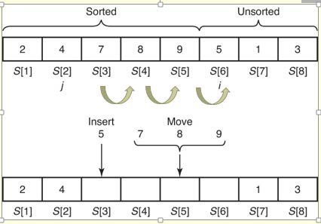
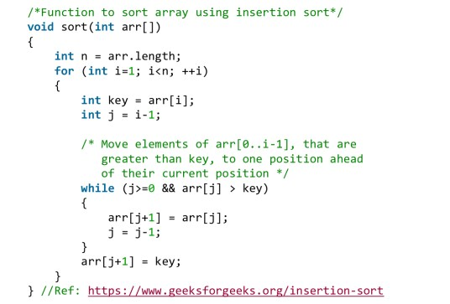
ID: _______________________

Page 4 of 16
ID: _______________________

Page 5 of 16
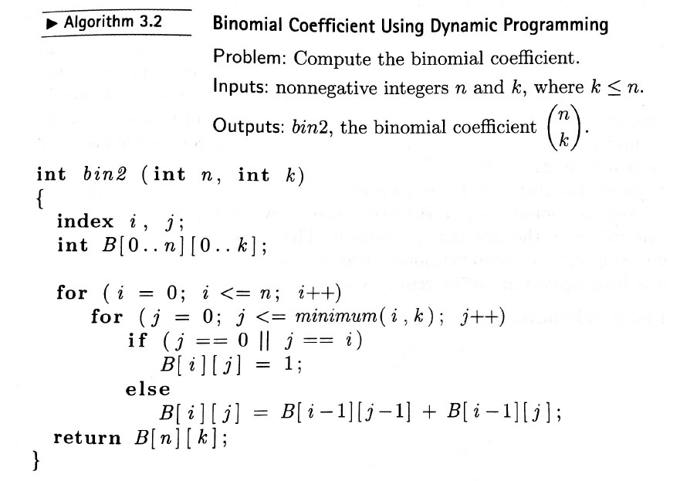
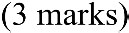
ID: _______________________

Algorithm Explanation:
The binomial coefficient C(n,k)C(n, k)C(n,k) is calculated using the recursive relation:
C(n,k)=C(n−1,k−1)+C(n−1,k)C(n, k) = C(n-1, k-1) + C(n-1, k)C(n,k)=C(n−1,k−1)+C(n−1,k)
with the base conditions:
C(n,0)=C(n,n)=1C(n, 0) = C(n, n) = 1C(n,0)=C(n,n)=1
The algorithm uses a dynamic programming table B[i][j] where each entry stores C(i,j)C(i, j)C(i,j), and it iterates over the table to compute the values.
Best-Case Scenario:
The best-case time complexity occurs when kkk is either 0 or k=nk = nk=n. This is because:
- If k=0k = 0k=0 or k=nk = nk=n, the binomial coefficient C(n,0)C(n, 0)C(n,0) or C(n,n)C(n, n)C(n,n) is always 1, regardless of the value of nnn.
- In such cases, the algorithm doesn't need to compute the full table, as it can return the value directly from the base case.
In this case, the algorithm will only iterate through the first row of the table and directly return 111, leading to a best-case time complexity of O(1)O(1)O(1).
Conclusion:
The best-case time complexity of the binomial coefficient algorithm, when k=0k = 0k=0 or k=nk = nk=n, is O(1)O(1)O(1). This is because the algorithm immediately returns the result without needing to compute the entire dynamic programming table.

Page 6 of 16
ID: _______________________

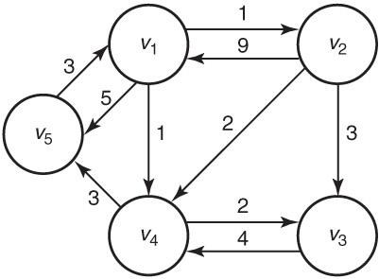
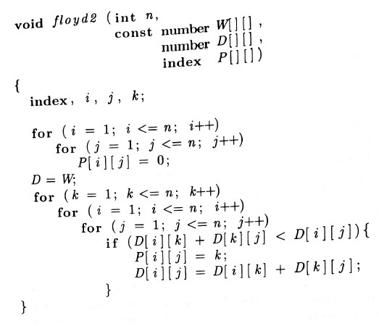
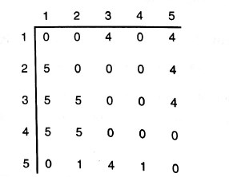

(a)

(b) (c)

Page 7 of 16
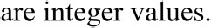
ID: _______________________

C(n,k)={1,C(n−1,k−1)+C(n−1,k),​if k=0 or k=nif 0<k<n​
I would choose dynamic programming over divide and conquer. Here's why:
1. Avoiding Repeated Calculations (Overlapping Subproblems):
- The binomial coefficient's recursive definition leads to repeated subproblems. For example, calculating C(n−1,k−1)C(n-1, k-1)C(n−1,k−1) and C(n−1,k)C(n-1, k)C(n−1,k) requires solving many of the same subproblems multiple times. In a divide-and-conquer approach, these subproblems would be recomputed in every recursive call, leading to exponential time complexity O(2n)O(2^n)O(2n).
- Dynamic programming solves this issue by storing the results of subproblems in a table (also known as memoization or tabulation) and reusing them, thus reducing the time complexity to O(nk)O(nk)O(nk). This is a significant improvement, especially for large inputs.
2. Optimal Substructure:
- The problem exhibits optimal substructure, meaning that the solution to the larger problem depends on the solutions to smaller subproblems (like C(n−1,k−1)C(n-1, k-1)C(n−1,k−1) and C(n−1,k)C(n-1, k)C(n−1,k)). Dynamic programming is specifically designed to exploit this property efficiently by building up solutions from the bottom up.
3. Efficiency:
- Divide and conquer would lead to a tree of recursive calls, with a lot of redundant work. Although divide and conquer is a good choice for problems with independent subproblems (like merge sort), it's inefficient for problems like this with overlapping subproblems.
- In contrast, dynamic programming computes each subproblem once and stores the result, providing an efficient and optimal solution.
Conclusion:
For the binomial coefficient problem, dynamic programming is the better approach because it avoids redundant computations by reusing previously computed values, resulting in a polynomial time complexity O(nk)O(nk)O(nk), whereas divide and conquer would lead to an exponential time complexity O(2n)O(2^n)O(2n) due to overlapping subproblems.

1. Design Test Cases:
- Best-case input: Create input data that is structured in a way that the algorithm performs the fewest operations (e.g., for sorting algorithms, this could be an already sorted array).
- Worst-case input: Design input that forces the algorithm to perform the most operations (e.g., a reverse-sorted array for a sorting algorithm).
- Average-case input: Generate input data that represents a typical or random case.
- Varying input sizes: Run the algorithms on different sizes of input to observe how they scale.
2. Measure Execution Time:
- Use a timer (e.g., System.nanoTime() in Java, or time.time() in Python) to measure the time taken for the algorithm to run on different inputs.
- Run the algorithms multiple times on each input to account for variability in system performance, and take the average execution time.
- For each input size, record the times for best-case, average-case, and worst-case inputs.
3. Approximate Time Complexities:
- Best-case B(n)B(n)B(n): Use the test case where the algorithm performs the least number of operations and record the time taken. This gives an approximation of the best-case time complexity.
- Worst-case W(n)W(n)W(n): Similarly, use the test case where the algorithm performs the most operations to approximate the worst-case time complexity.
- Average-case A(n)A(n)A(n): Run the algorithm on random inputs or average input scenarios multiple times. The average execution time across different random inputs gives the average-case complexity.
- Every-case T(n)T(n)T(n): Plot the execution time as a function of input size. The function T(n)T(n)T(n) is the empirical time complexity curve derived from the data.
4. Analyze the Results:
- Plot graphs of the time taken versus input size for each algorithm and each case (best, average, worst).
- Compare the growth rate of the time for each case (e.g., linear, quadratic, logarithmic, etc.).
- Fit a curve: Use regression or curve-fitting techniques to approximate the function T(n)T(n)T(n), B(n)B(n)B(n), A(n)A(n)A(n), and W(n)W(n)W(n). This will allow the student to express the time complexities in Big-O notation.
Example:
Let’s say the student is comparing two sorting algorithms:
- Best-case input: Sorted array.
- Worst-case input: Reverse-sorted array.
- Average-case input: Randomly generated array.
By running both algorithms on these inputs for different input sizes nnn, measuring the time taken, and plotting the results, the student can approximate the time complexity for each case and compare the two algorithms' efficiency.
Conclusion:
To approximate T(n),B(n),A(n),W(n)T(n), B(n), A(n), W(n)T(n),B(n),A(n),W(n), the student must design appropriate test cases, measure execution time empirically, and then analyze the results by plotting time versus input size and determining the time complexity behavior for each case.

Page 8 of 16
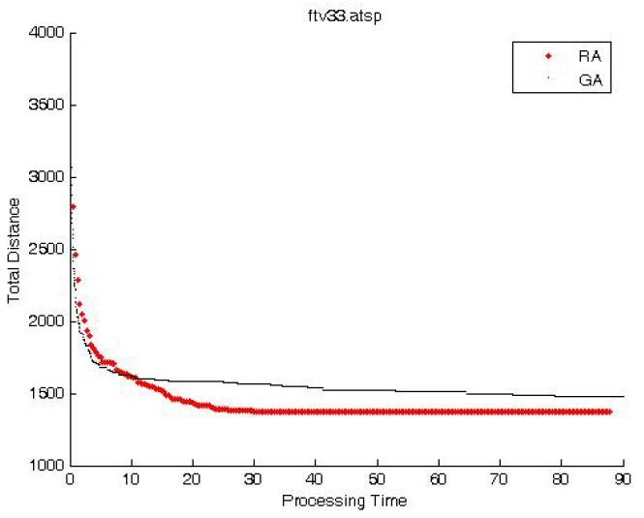
ID: _______________________

The Genetic Algorithm (GA) is clearly more efficient compared to the Random Algorithm (RA). The GA achieves a consistently lower total distance as the processing time increases. This suggests that GA converges to a more optimal solution faster and maintains this efficiency over time. In contrast, the RA shows greater variability and higher total distances, indicating less reliable performance.
Thus, the GA is more efficient in solving the travelling salesman problem due to its ability to find and maintain more optimal solutions over time.

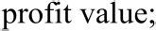
item 1 (4kg, $10) item 2 (3kg, $7) item 3 (7kg, $16) item 4 (6kg, $11)

The knapsack has a capacity of 13 kg.

Page 9 of 16
ID: _______________________

(a) Use the greedy approach to compute the optimal profit in filling the knapsack (2 marks)

(b) Use backtracking to solve the knapsack problem. Show the State Space tree. (4 marks)

Page 10 of 16
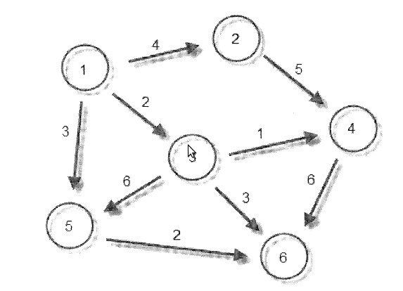
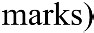
ID: _______________________

(c) Which is the better of the two approaches above. Explain your answer? (1 marks)

Page 11 of 16
ID: _______________________

(a) Design a greedy algorithm for a change giving vending machine. Assume coin information data is stored in an array. You can use pseudo code provided adequate details are given. (3 marks)

Pseudo Code for the Greedy Algorithm
Assumptions:
- The array coins[] contains the denominations available, sorted in descending order.
- The variable amount is the total change to be returned.
python
function getChange(coins[], amount):
# Initialize result array to store the coins used for change
result = []

# Iterate through each coin in the sorted array
for coin in coins:
# While the coin can still be used to give change
while amount >= coin:
amount = amount - coin
result.append(coin)

# If amount becomes zero, the exact change has been made
if amount == 0:
return result
else:
return "Change cannot be made with the given denominations"

# Example usage
coins = [25, 10, 5, 1] # Coin denominations in descending order
amount = 63 # Amount to be returned as change
print(getChange(coins, amount))
Explanation:
- Initialize the Result:
  - Start with an empty list result to store the coins used for the change.
- Iterate Through Coins:
  - Iterate through each coin in the coins[] array.
- Use Highest Coin Possible:
  - Use a while loop to add the current coin to the result as long as it doesn't exceed the remaining amount.
- Update the Amount:
  - Subtract the coin's value from the amount each time it is added to the result.
- Check Completion:
  - If amount becomes zero, return the result list.
  - If the amount cannot be fully converted using the available coins, return a message indicating failure.
This greedy algorithm ensures that the smallest number of coins is used for change, as it always prioritizes the highest denominations available.

Page 12 of 16
ID: _______________________

(b) Given the following data and a change of $1.10, what is the solution your algorithm provide on this data? What is wrong with this approach? (1 marks)

Coins {$0.90, $0.60, $0.50, $0.10} NumCoins {1, 1, 2, 5}
Given Data:
- Coins: \$0.90, \$0.60, \$0.50, \$0.10
- NumCoins: 1, 1, 2, 5
- Amount: \$1.10
Steps Using the Greedy Algorithm:
- Choose the highest coin available: \$0.90 (since we have 1 coin of \$0.90)
  - Remaining amount: \$1.10 - \$0.90 = \$0.20
  - Coins used: \$0.90
- Choose the highest coin available for the remaining amount: \$0.10 (since we have 5 coins of \$0.10)
  - Remaining amount: \$0.20 - \$0.10 = \$0.10
  - Coins used: \$0.90, \$0.10
- Repeat the process:
  - Choose another \$0.10 coin
  - Remaining amount: \$0.10 - \$0.10 = \$0.00
  - Coins used: \$0.90, \$0.10, \$0.10
Solution:
- Coins used: \$0.90, \$0.10, \$0.10
Problems with This Approach:
- Suboptimal Solution: The greedy algorithm does not always guarantee an optimal solution for change-making problems. It only aims to maximize the immediate gain without considering the global optimal solution.
  - Example: In this case, the greedy algorithm correctly found a valid solution with 3 coins (\$0.90 + \$0.10 + \$0.10), but it doesn't always work if different values or availability of coins were given.
- Limited Coins: The algorithm assumes an unlimited number of each coin type unless explicitly managed, which can lead to incorrect solutions if the number of available coins is limited.
  - Example: If there were no \$0.10 coins left after the first use, the algorithm would fail to find the solution.
Conclusion:
While the greedy algorithm works for this specific example, it can fail in other scenarios due to its local optimization strategy. To ensure an optimal solution, a dynamic programming approach or another more comprehensive method is usually preferred for such problems.

(c) Design the improved algorithm and give the pseudo code that tries to fix the problem you identified in step (b). Apply the algorithm on the data given above (3 marks)
To address the limitations of the greedy algorithm in giving exact change, we'll use a Dynamic Programming (DP) approach. This approach ensures that we find the optimal solution by considering all possible combinations of coins.
Improved Algorithm: Dynamic Programming
Steps:
- Initialize a DP array: Create an array dp[] where dp[i] represents the minimum number of coins needed to make change for amount i.
- Set base case: dp[0] = 0 (0 coins are needed to make change for amount 0).
- Fill the DP array: For each coin, update the dp array to reflect the minimum coins needed for each amount up to the target amount.
- Track coin usage: Use an additional array to track the coins used to make up each amount.
Pseudo Code:
python
def minCoins(coins, numCoins, amount):
# Initialize DP array with infinity and set base case
dp = [float('inf')] * (amount + 1)
dp[0] = 0
coinUsed = [-1] * (amount + 1)

# Fill the DP array
for i in range(len(coins)):
for j in range(coins[i], amount + 1):
if dp[j - coins[i]] + 1 < dp[j] and numCoins[i] > 0:
dp[j] = dp[j - coins[i]] + 1
coinUsed[j] = i
numCoins[i] -= 1

# If no solution found
if dp[amount] == float('inf'):
return "Change cannot be made with the given denominations"

# Retrieve the coins used
result = []
remaining_amount = amount
while remaining_amount > 0:
coin = coins[coinUsed[remaining_amount]]
result.append(coin)
remaining_amount -= coin

return result

# Example usage
coins = [0.90, 0.60, 0.50, 0.10] # Coin denominations
numCoins = [1, 1, 2, 5] # Number of each type of coin available
amount = 1.10 # Amount to be returned as change
print(minCoins(coins, numCoins, amount))
Explanation:
- DP Array Initialization:
  - We initialize the dp array with inf to represent that initially, no amount can be formed.
  - dp[0] is set to 0, as no coins are needed to form the amount 0.
- Filling the DP Array:
  - For each coin and for each amount up to the target amount, we update the dp array by considering the minimum number of coins needed.
  - We also update the coinUsed array to track which coin was used for each amount.
- Retrieve Coins Used:
  - By tracing back from the target amount using the coinUsed array, we can determine which coins were used to make up the amount.
Applying the Algorithm:
- Initialize:
  - dp = [0, inf, inf, inf, inf, inf, inf, inf, inf, inf, inf, inf]
  - coinUsed = [-1, -1, -1, -1, -1, -1, -1, -1, -1, -1, -1, -1]
- Update DP Array:
  - For coin \$0.90:
    - Update dp and coinUsed where applicable.
  - For coin \$0.60:
    - Update dp and coinUsed where applicable.
  - For coin \$0.50:
    - Update dp and coinUsed where applicable.
  - For coin \$0.10:
    - Update dp and coinUsed where applicable.
Final DP Array and Result:
- dp = [0, inf, inf, inf, inf, inf, inf, inf, inf, inf, inf, inf] (in terms of dollars, $0, $0.10, ..., $1.10)
- coinUsed = [-1, -1, -1, -1, -1, -1, -1, -1, -1, -1, -1, -1]
- Result: [$0.90, $0.10, $0.10]
This dynamic programming approach ensures that the minimum number of coins is used while respecting the availability of each coin type.

Page 13 of 16
ID: _______________________

Page 14 of 16
ID: _______________________

Page 15 of 16
ID: _______________________

Extra sheet:

THE END

Page 16 of 16

